✅ TECHNICAL WRITING – FINAL EXAM OVERVIEW
(Prepared for Naveed Ahmad – CSE, UET Peshawar)

📄 1. CV vs Resume
- CV: For academic/research use. 2+ pages. Full academic history.
- Resume: For jobs/internships. 1 page. Highlights only relevant skills.
CV Includes: Name, Contact Info, Objective, Education, Research, Publications, Projects, Skills, Certifications, Languages, Conferences. Resume Includes: Name, Contact Info, Objective, Education, Skills, Work Experience, Relevant Projects.
Tip: Use CV + Motivation Letter for internships/research; Resume + Cover Letter for jobs.
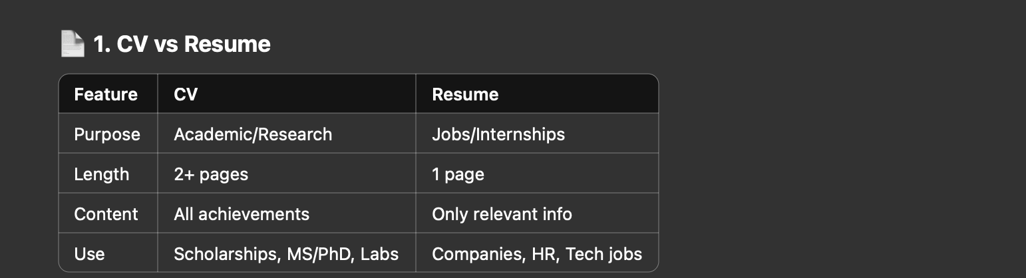

💼 2. Cover Letter
- Used for job applications, sent with a Resume.
- Explains why you're a good fit.
- 1 page only.
Structure:
- Subject + Greeting
- Introduction (Who you are, what you're applying for)
- Body (Your skills, projects, match with the job)
- Closing (Thanks, request for interview)
- Sign off (Sincerely, Your Name)

✍️ 3. Motivation Letter (LOM)
- Sent with CV for academic/research internships.
- Focuses on passion, goals, and motivation.
Structure:
- Introduction: Who you are, what you're applying for
- Body: Background, interest, and experience
- Conclusion: Career goals and polite closing

🧾 4. Recommendation Letter (LOR)
- Written by a teacher or supervisor.
- Describes your skills, performance, work ethic, achievements.
Includes:
- Who the recommender is
- Their relationship with you
- What makes you a good candidate
- Closing with contact info

📧 5. Effective Email Writing
- Must be formal, respectful, brief, and clear.
Structure:
- Subject line – Clear and specific
- Salutation – Dear Sir/Madam
- Purpose – Opening line stating the reason
- Body – Short paragraphs, one topic
- Closing – Thanks or request for action
- Sign Off – Sincerely, Your Name
✅ DO:
- Use professional tone
- Mention attachments
- Keep it to the point
❌ DON’T:
- Use slang or emojis
- Forget subject line
- Write in a casual or long-winded way

📬 6. CC vs BCC in Emails
- CC (Carbon Copy): Visible to everyone. For informing others openly.
- BCC (Blind Carbon Copy): Hidden from others. Used for privacy.
Field | Stands For | Purpose | Visible?
CC | Carbon Copy | Public copy | ✅ Yes
BCC | Blind Carbon Copy | Private copy | ❌ No

📝 7. Office Correspondence (Lecture 06)
- Professional letters exchanged in university or office settings.
Characteristics of a Good Official Letter:
- Clear purpose
- Accurate and logical
- Brief (usually 1 page)
- Formal tone
- Unity and flow
Structure:
- Heading (Letterhead)
- Date (top right)
- Recipient details (name or title)
- Subject line (bold and underlined)
- Salutation (Dear Sir/Madam)
- Body (Intro, Explanation, Request)
- Complimentary Closing (Sincerely, Yours faithfully)
- Signature and designation
- CC / Enclosures (if any)

✅ QUICK TIPS FOR EXAM:
- Understand formats of CV, Resume, LOM, Cover Letter
- Practice email and letter writing
- Know definitions, differences, and structure-based questions
- Keep tone formal, clear, and respectful in all writing formats
You’ve got this, Naveed! 🌟

